Content Addressable Memory (CAM) or Associative memory
.
- This type of memory is accessed simultaneously and in parallel on the basis of data content rather than by specific address or location.
- When a word is written to associative memory no address is given. The memory is capable of finding an empty unused location to store the word.
- When a word is to be read from an associative memory, the content of the word, or part of the word is specified. The memory locates all words which match the specified content and marks them for reading.
- An associative memory is more expensive than a random access memory, so are used in application where search time is very critical and must be very short.

Hardware Organization

- It consists of a memory array and logic for m Words with n bits per word.
- Argument register (or Data register) A and key register K Each have n bits.
- The match register M has m bits, one for each memory word.
- Each word in the memory is compared in parallel with the content of the argument register. The words that match the bits of the argument register set a corresponding bit in the match register. Then reading is accomplished by a sequential access to memory. (However, for the applications of associative memory in cache and virtual memory, at most one match will occur)

Key register (tag register)
- It provides a mask for choosing a particular field or key (tag) in the argument word.
- The entire argument is compared with each memory word if the key register contains all 1's. Otherwise, only those bits in the argument that have 1's in their corresponding position of the key register are compared.
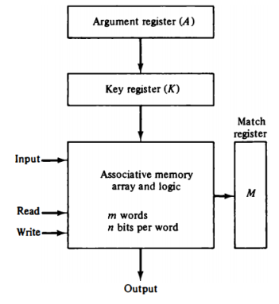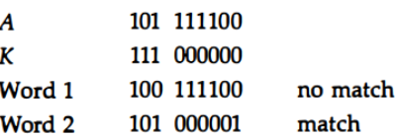

Relationship between the memory array and external registers

- Cell $C_{ij}$, is the cell for bit j in word i. A bit $A_{j}$, in the argument register is compared with all bits in column j of the array provided that $K_{j}$=1.
- This is done for all columns j=1,2....,n. If match occurs between all the unmasked bits of the argument and the bits in word I, then set $M_{i}$ to 1.
Otherwise set $M_{i}$ to 0.

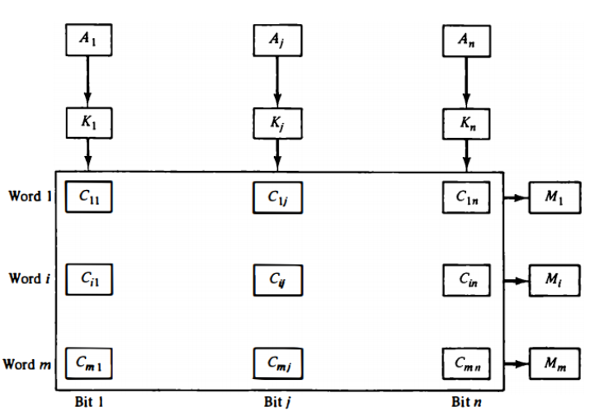

Match Logic

It consists of a flip flop storage element $F_{ij}$ and circuit for reading, writing and matching the cell

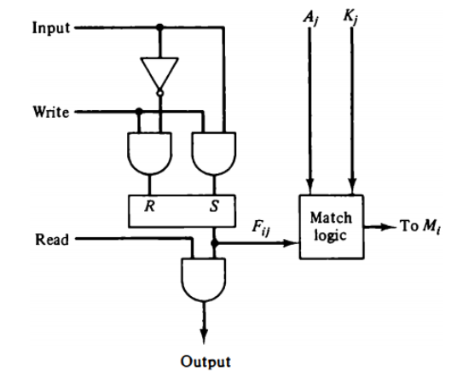
Fig: One cell of associative memory

Word i is equal to the argument in A if $A_{j}$ = $F_{ij}$ for j = 1, 2,..,n. Two bits are equal if they are both 1 or both 0. The equality of two bits can be expressed logically by Boolean function.
$x_{j}$ = $A_{j}F_{ij}$+ $A_{j}^{'}F_{ij}^{'}$
where $x_{j}$ = 1 if the pair of bits in position j are equal; otherwise, $x_{j}$=0.
For a word i to be equal to the argument in A we must have all $x_{j}$ variables equal to 1. This is the condition for setting the corresponding match bit $M_{i}$ to

Boolean function for this condition is
$M_{i}$ = $x_{1}$. $x_{2}$….$x_{n}$

If $K_{j}$ = 0, the corresponding bits of A and F, need no comparison.
Only when $K_{j}$ = 1 must they be compared. This requirement is achieved by ORing each term with $K_{j}^{'}$, thus
$x_{j}$ +$K_{j}^{'}$ = $x_{j}$ if $K_{j}$ = 1
= 1, if $K_{j}$ = 0

The match logic for word i in an associative memory can now be expressed by the following Boolean function.
М, = [x1 + $K_{1}^{'}$) (x2 +$K_{2}^{'}$) (x3 +$K_{3}^{'}$) ... (хn+ $K_{n}^{'}$)
If we substitute the original definition of xj
Mi = $\prod_{1}^{n}{(A_{j}F_{ij}+ A_{j}^{'}F_{ij}^{'}}+K_{j}^{'}$)
where $π$ is a product symbol designating the AND operation of all n terms.
• Each cell requires 2 AND gets and one OR gate. The inverters for Aj and Kj are needed once for each column and are used for all bits in the column. The output to all OR gates in the cells of the same word go to the input of the common AND get to Generate the match signal for Mi.

Read and write operation in Associative memory

Read Operation
- If more than one word in memory matches, then read in sequence by applying read signal to each word line with $M_{i}$ =1.
- If only one word may match, connect output M; directly to the read line in the same word-position.
Write Operation
- Writing in an associative memory can take different forms. If entire memory is loaded with new information, then writing can be done by addressing each location in sequence.
- If unwanted words have to be deleted and new words inserted one at a time using tag register.
- A word is deleted for memory be clearing its tag bit to 0. After the new word is stored in memory it is made active by setting its tag bit to 1.

